Trip to Paris, France

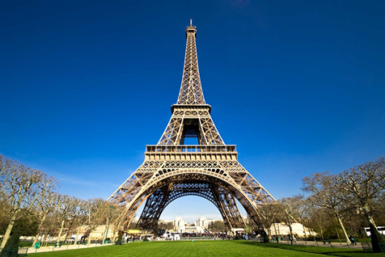

Summer Trip 2015

Whether you're looking for a romantic getaway or hoping to explore one of Europe's most popular destinations, Paris offers the best of both worlds. Explore the city's maze of fascinating and historical sights. Lose yourself in the world-famous Louvre, see the splendor of Versailles, and make your mark at the Moulin Rouge. After an evening stroll along the Seine, set your sights on Paris's Left Bank, where dining and entertainment options reach their peak.

July 21, 2015

Hotel Da Vinci, 25 rue des Saints Peres, 75006 Paris, France

www.TripAdvisor.com